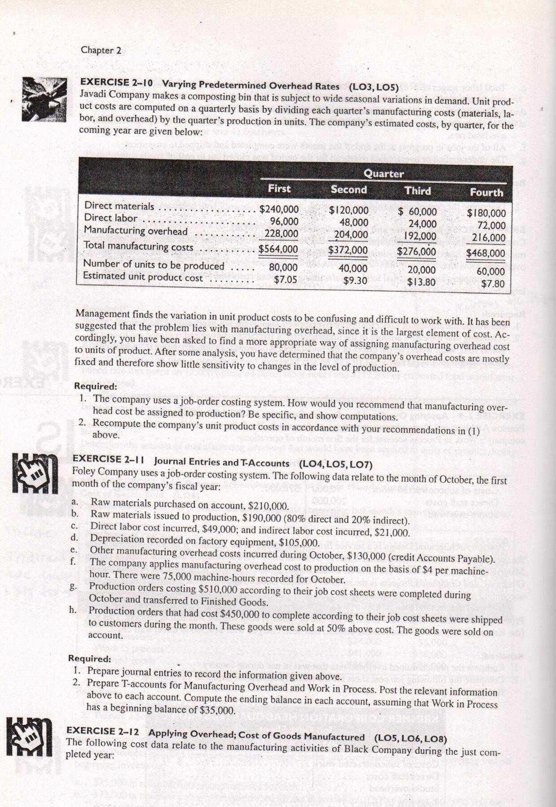



Work in process, beginning $6,000

Work in process, ending $7,500

38.000

37.000

.

. 540›000

. .

Direct labor cost Inventories:

Raw maceriaTs, beginning . . . . . . . . . . . .

Raw materials, ending

Uttl\ties, factory 5,000

*In* di *rec c Zabo t* . . I 0,000

Depreciation. factory . 24,000 Insurance. factory . . . . . . . . . . . . . . . . . . . , 6,000

Total accual manufacturing overhead coscs . $48,000

Other costs incurred

Purchases of raw materials $32,000

. $ 3,000

fflanufacturing overhead costs: Proper ry taxes, factory

The coin pa ft y near s'p fedctei in i rrel ove il›ca if r.e to apply ovc rli cold cost to {›roduc tiorJ . ’1 lje r;ile top the y»ai was $5 per ni acIiin e-ho ur; a ical o1' I 0,000 n ac hit ie lv ours w its recorded ter nil year.



1. don q7 tile I lie amount of under- or verljpp Ired overfiead cos t for i he year

2 Pre pare it schedule of' cost of goods iniiniifactured for the year.

EX ERCtSE 7- 18 Applying Overhead with Various Bases (LOW, LOW, LOB)

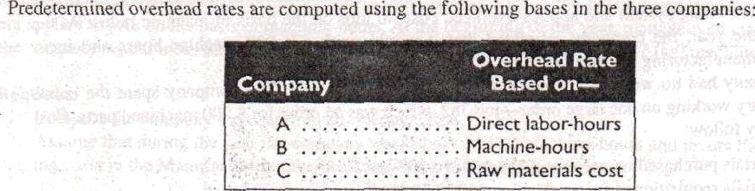

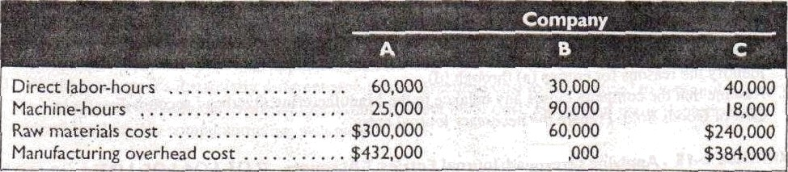

$270

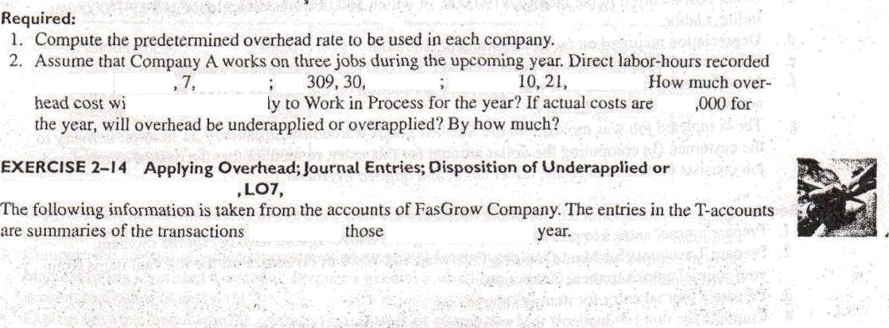

by job ure: job 3OS t100 hotirs job

11 the company app'

00(J hours anal Job 3

Lf()t) hours.

$420

Overapplied Overhead (LO4 LOB)

that aflee ted

accot nls during the

Thank you for using [www.freepdfconvert.com](http://www.freepdfconvert.com/) service!

Only two pages are converted. Please Sign Up to convert all pages. <https://www.freepdfconvert.com/membership>